Sr. No. | Question
1. | Reduce the following matrix to row echelon form (row reduce form) and hence determine the rank. How many pivot elements are there? State the column numbers where you observed the pivot elements.  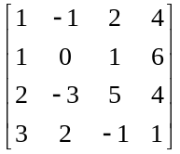.
2. | Construct a matrix of order 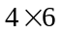as follows.  i) The first row of the matrix contents any six numbers from date of last Saturday of November 2022.  ii) The second row elements of the matrix are 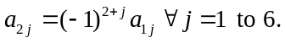  iii) The third row elements of the matrix are 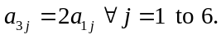  iv) The fourth row elements of the matrix are 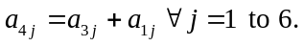  Reduce the constructed matrix to row echelon form (row reduce form) and hence determine the rank. How many pivot elements are there? State the column numbers where you observed the pivot elements.
3. | Determine real values of so that the system of equations have non-trivial solution 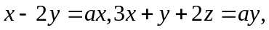and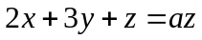. Solve the system for this value of.  Draw the graph of above equations for this value of using any free online graphical software and show the solution graphically.
4. | Determine the possible conditions on 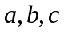 and so that the matrix 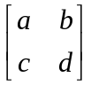 is  i) equivalent to 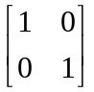 ii) equivalent to 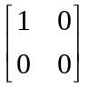.
5. | Determine whether the following set of equations possesses non-trivial solution. Draw the graph of above equations using any free online graphical software and show the solution graphically.  .
6. | i) Use any free graphical software to graph the system 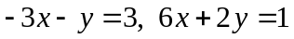  ii) Use the graphs to determine whether the system is consistent or not.  iii) If the system is consistent, show the approximate solution graphically.  iv) Solve the system algebraically also.  v) Compare the solution obtained in step (iii) and step (iv). Write your  conclusion.
7. | i) Use any free graphical software to graph the system 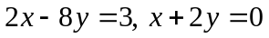  ii) Use the graphs to determine whether the system is consistent or not.  iii) If the system is consistent, show the approximate solution graphically.  iv) Solve the system algebraically also.  v) Compare the solution obtained in step (iii) and step (iv). Write your  conclusion.
8. | Find the values of 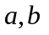 and such that the system of equations has  i) exactly one solution ii) infinite solutions iii) no solution.  .  Draw the graph of above equations using any free online graphical software for each of the above situations.
9. | Determine the values of such that the following system of equations does not have a unique solution.  .  Solve the system for these values of. Draw the graph of above equations using any free online graphical software and show the solution graphically
10. | Investigate the values of 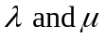such that the system  has  i) No solution ii) A unique solution iii) An infinite solutions
11 | Investigate for consistency and if possible find solution
12 | Investigate for consistency and if possible find solution
13 | Investigate for consistency and if possible find solution
14 | Determine which of the following matrices are in reduced echelon form and which are in echelon form.  i) 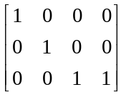 ii) 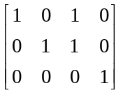 iii) 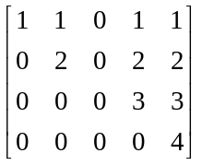 iv) 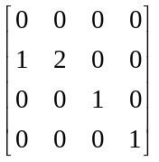
15 | Find the general solution of the system whose augmented matrix is  i) 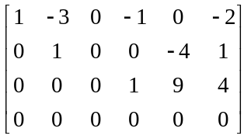 ii) 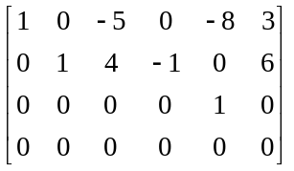 iii) 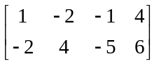
16 | Consider the following system .  Write the system in matrix form. Perform the following sequence of operations on rows of augmented matrix.  Write the reduced system. Solve the system completely.
17 | Find the constrains on and so that the following system is consistent.  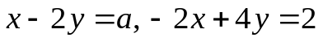
18 | Find the constrains on 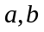 and so that the following system is consistent.
19 | Find the point where the three lines 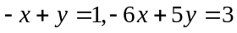and 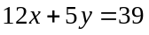intersect. Sketch the lines.
20 | Determine the values of such that the linear system  has  a. A unique solution  b. A one-parameter family of solutions  c. A two-parameter family of solutions

